Understanding Nonprofit Financial Statements
JANUARY 11, 2016 BY JAMES WILLIS
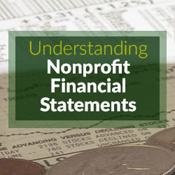

Whether you are starting a new job at a nonprofit organization, joining a nonprofit Board of Directors, or looking to donate money to a charity, it’s important to familiarize yourself with the unique way in which nonprofits present their financial statements. Although most individuals have a general understanding of accounting and the accounting principles, it’s interesting to note that most of what we learn, especially in accounting courses, is generally geared towards for-profit companies, and, as you will see, the way in which nonprofits present their financial statements is a bit unique.
Let’s start with the Statement of Financial Position. This statement is similar to the for-profit world’s Balance Sheet in that it lists the values of all the assets held by the organization and the values of all the debts owed, but the Statement of Financial Position also reports the organization’s net assets. Similar to equity, the net assets section denotes the “value” of the nonprofit. This value, however, is further divided on the Statement of Financial Position into restrictions – either temporarily restricted, permanently restricted, and unrestricted net assets. These classifications are used to segregate funding based on any restriction(s) imposed by each donor as to how the funds can be spent. For example, if an individual donates money to a nonprofit organization and limits how the organization can use the funds, that money is considered restricted solely for that purpose. Depending on the nature of the donor-imposed restriction, these funds may be permanently restricted (such as endowments that cannot be spent) or temporarily restricted (such as funds that are to be spent, not held, on a specific project). On the other hand, if an individual donates money to an organization but never specifies on what or how the organization can use the funds, these funds have no restrictions and are therefore classified as “unrestricted”. It is interesting to note that occasionally funds are restricted internally (i.e., management or the Board of Directors decides to restrict how some of the unrestricted funds are to be spent). The funds are still considered unrestricted for reporting purposes but the internal restriction is noted in the Statement or in the accompanying notes (such as in the example below whereby the Board of Directors restricted $1M of the organization’s unrestricted funding for a given purpose).
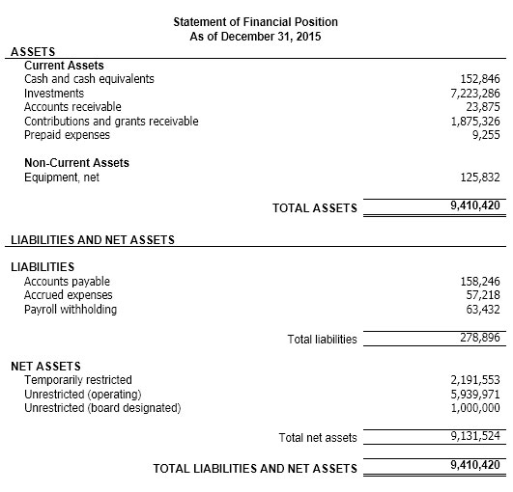
It is important to note when reviewing financial statements that some smaller nonprofit organizations, especially those not using a fund accounting system, may produce financial statements with the term “fund balance” instead of “net assets”. They may also fail to properly disclose the “fund balance” by restriction; however, this is usually corrected on the audited financial statements prepared by the external auditing firm.
In addition to segregating net assets based on restrictions, the Financial Accounting Standards Board (per Statement of Financial Accounting Standards No. 117) requests organizations to further report — either in the net assets section of the Statement of Financial Position or within the financial statement notes — any assets that are donated to the organization with “stipulations that they be used for a specified purpose, be preserved, and not be sold” (i.e., land or works of art) or assets donated with “stipulations that they be invested to provide a permanent source of income” (i.e., endowments).
The next financial statement that you will see presented after the Statement of Financial Position is the Statement of Activities. This statement is in lieu of the Income Statement that is used by for-profit companies, and it reports the change in permanently restricted, temporarily restricted, and unrestricted net assets. As shown below, this is accomplished by listing each net asset fund in a separate column. Expenses, which are by nature considered “unrestricted” even if they were spent with restricted funds, will appear solely in the unrestricted column, and the revenues tied to those expenses incurred using restricted funds will appear in the line item “net assets released from restrictions”. Accountants will typically state that those revenues were “released” from their donor-imposed restrictions once the expenses were incurred, thus the Statement of Activities will present a decrease in these restricted funds and an increase in the unrestricted funding for the same amount in the revenue section of the statement (as seen in the example below).
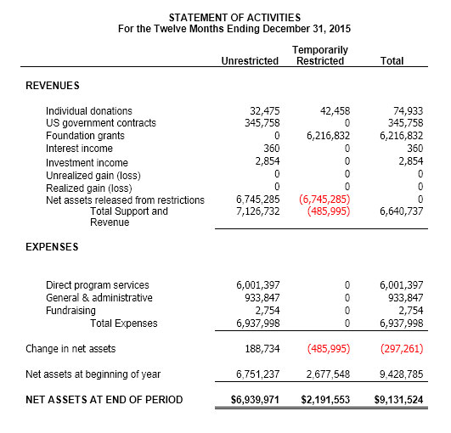
As opposed to an Income Statement which shows a profit or loss, the Statement of Activities instead shows a positive or negative change in each net asset fund. In the example above, you will see that the amount of temporarily restricted revenue collected during the reporting period was less than the expenses incurred using temporarily restricted funding (the sum of the temporarily restricted revenues is less than the amount of temporarily restricted revenue released from restrictions). Thus, there is a drop in the ending balance of the temporarily restricted net assets. Individuals used to reading for-profit financial statements typically consider this a “loss”; however, nonprofits are not in the business of making a profit (or a loss), thus this is an incorrect assumption. Instead, the financial statement is showing that the organization expended some of the net assets that were obtained in a prior financial period(s). This is not a loss but utilizing funds for their intended purpose (thus meeting the donor-imposed restrictions). If you are interested in assessing the organization’s financial stability, it is best to analyze the financial statements for the past five or so years to ascertain if the organization has been consistently utilizing its net assets and not replenishing them with additional funding as this could possibly indicate long-term instability.
As noted earlier, net assets denote the value of the organization. However, since restricted net assets cannot easily be used by the organization (without satisfying the donor-imposed restrictions), it is quite common in the nonprofit world to consider the organization’s unrestricted net assets to be the actual value of the organization. Thus, if the organization had to close its doors, those unspent funds held that were restricted for use would have to be returned to the donors since the organization did not earn them.
Lastly, to show the correlation between the two financial statements that we covered, you will notice that the ending value of each net asset fund listed on the Statement of Activities matches the same amount listed on the Statement of Financial Position.
Another financial statement produced by nonprofit organizations is the Statement of Cash Flows, which is produced following the same procedures used by for-profit companies. This statement shows the inflow and outflow of cash within the organization. As shown in the sample statement below, the cash flow starts with the change in net assets – which equals the amount listed on the Statement of Activities. The changes in the balance sheet accounts are then added to this amount to derive at the total increase or decrease in cash. When this total amount is added to the cash balance at the beginning of the reporting period, you will end up with the current cash balance, which will match the amount listed on the Statement of Financial Position.
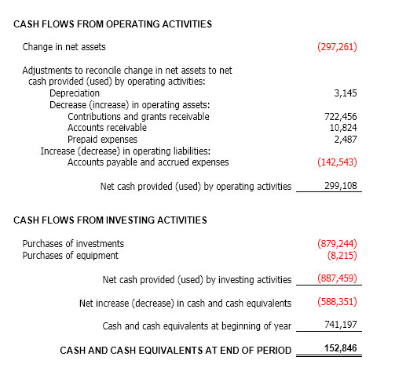
Finally, nonprofits will also produce a Statement of Functional Expenses. This statement will detail the expenses incurred during the reporting period and allocate it by program services and support services. Best practice, although not required, is to break-out the program service costs by the organization’s various programs and list the expense categories from highest to lowest. Program services are considered “direct costs” as they are the mission-related activities performed by the organization, while support services include such costs as fundraising, overhead, management and/or general administration.
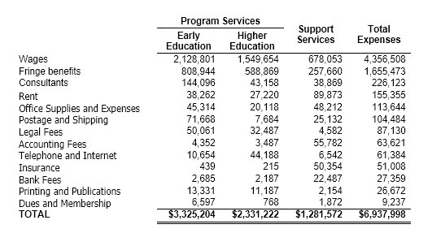
Again, all of the financial statements are connected. For the Statement of Functional Expenses (as shown in the example above), the total expenses will equal the same amount reported on the Statement of Activities.
These four statements represent the primarily financial statements that nonprofit organizations prepare; however, some may include additional statements that provide even more insight into the organization’s finances. Familiarizing oneself with how these financial statements are developed will undoubtedly help users better understand a nonprofit organization’s financial position. And, from this standpoint, users can more easily begin to interpret the statements through such techniques as common-sizing and performing ratio analyses to get a better understanding of how the organization is performing financially – a key skillset for anyone working or doing business with a nonprofit.

